3.1.1 User login & auth Class Diagram

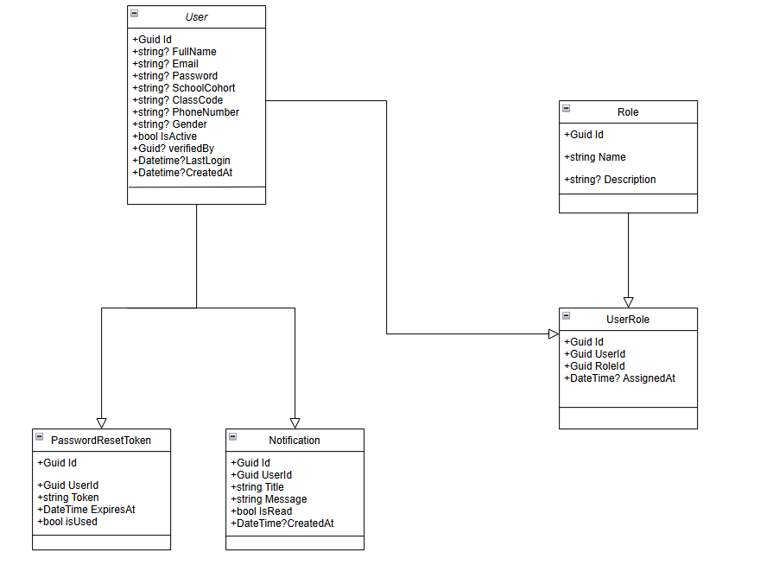

3.1.2 Medical case & visual Q&A Class Diagram
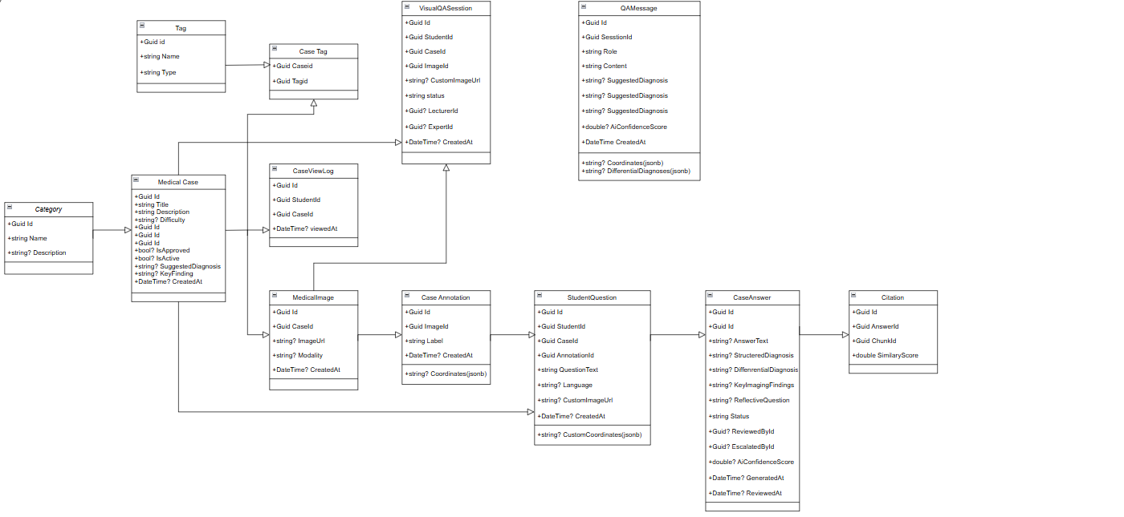

3.1.3 Knowledge base & RAG Class Diagram
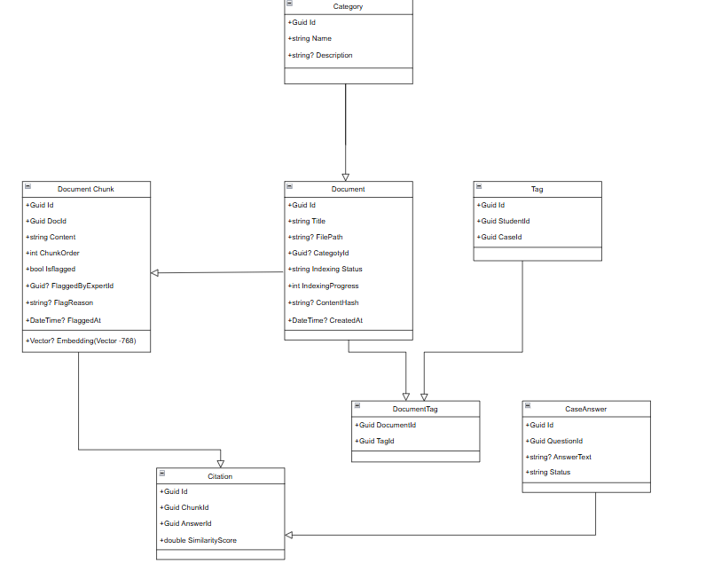

3.1.4 Learning & Quiz Class Diagram

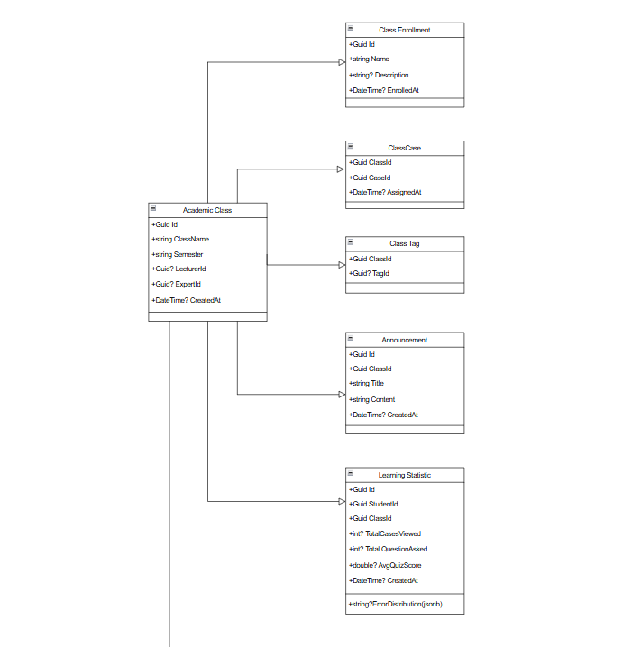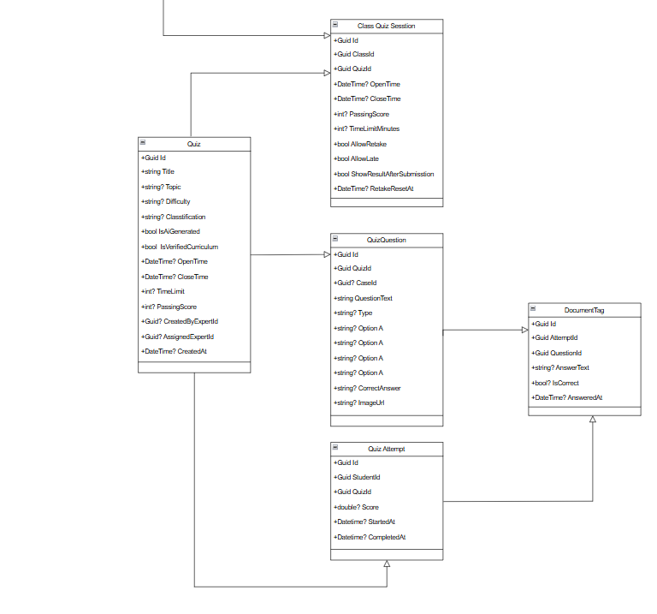

3.2 Sequence Diagram

3.2.1 Sequence Diagram – User Login
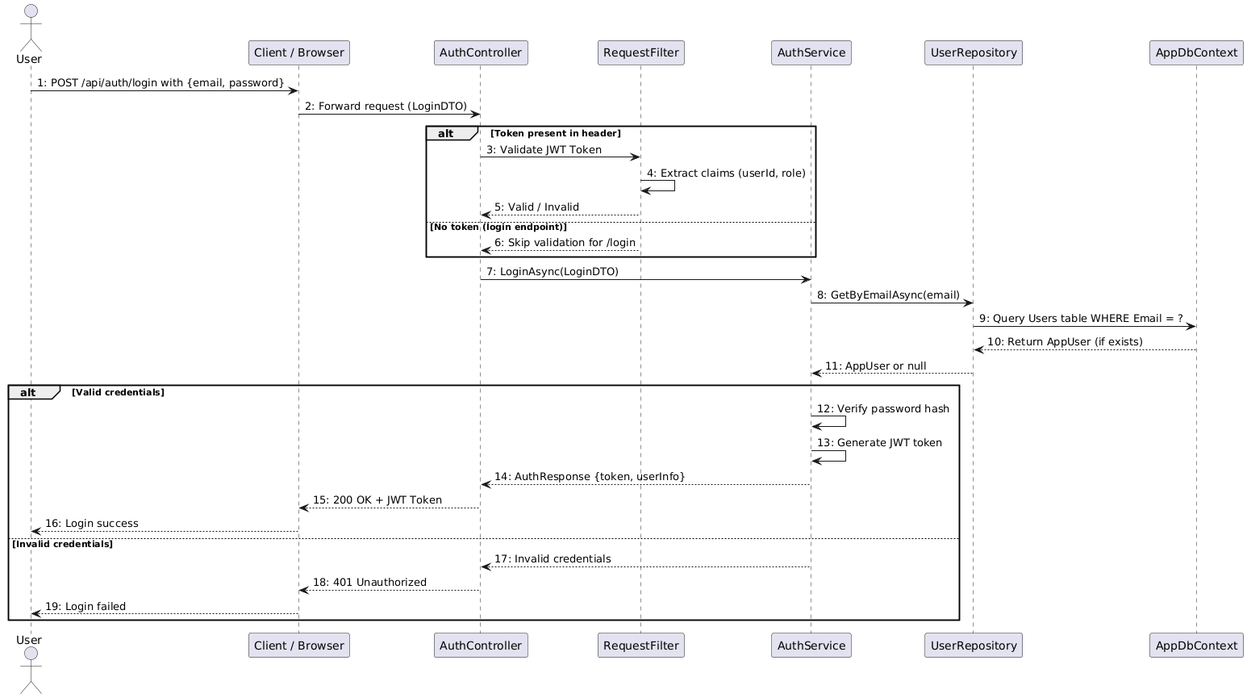

3.2.2 Sequence Diagram – User Registration
